D-M-12-F

Material and plating
Connector parts Material Plating
Center contact Brass Ag
Outer contact Brass CuSnZn
Fastener Brass Ni
Dielectric PTFE -
Gasket Silicon -

Technical Specifications
Operating Frequency Band | ≥ 3.6Ghz
Insertion Loss | ≤0.05dB
Impedance | 50 Ω
Contact resistance | Center contact≤ 0.4mΩ  Outer contact≤ 0.2mΩ
Insulation Resistance | ≥ 10000 MΩ
PIM3 | ≤-155dBc@2*20W
Return Loss (dB) | 50MHz~1000MHz: ≥ 35  1000MHz~1900MHz: ≥ 32  1900MHz~2200MHz: ≥ 32  2200MHz~2700MHz: ≥ 32
Interface | 7-16 DIN Male
Bod Style | Straight
Peak Power in Maximum(kW) | ≥ 0.7
RF Operating Voltage in maximum | ≥ 500 vrms
Mating cycles | 500
Dielectric Strength | 2000 V, AC, 1Min
Operating Temperature | -45~+85 °C
Relative Humidity | 0~95 %
Application | Indoor or Outdoor (IP68)
Change of temperature | IEC 60068-2-14/GB/T 2423.22
Salt mist | IEC 60068-2-11/GB/T 2423.17
Vibration | IEC 60068-2-6/GB/T 2423.10
Shock | IEC 60068-2-27/GB/T 2423.5
Damp heat, steady state | IEC 60068-2-3/GB/T 2423.3
Protection class | IEC 60529/GB 4208
Suitable cables | 1/2’’ Feeder  applicable for cable feeder : Feeders: Smooth solid tube / smooth round solid, Outer Conductor / Ring corrugated copper tube, Inner Conductor / 4.8 ± 2% mm core conductor, Outer Conductor / Shell Conductor diameter 13.8 ± 2% mm, Jacket / plastic sheath, diameter 15.8 ± 2% mm, Outer Conductor / SIN wave conductor / SIN waveform, Dielectric / Insulation between the core conductor and the sheath conductor Polyethylene Foam
Weight(g) | ≥ 96

Drawing
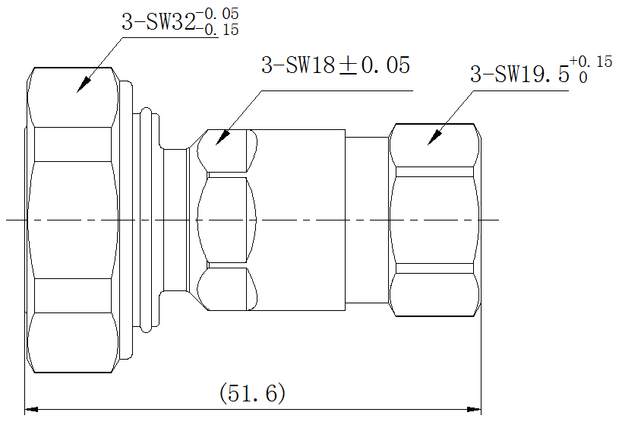

According to IEC 61169-4

